**NJ.com’s Girls Wrestler of the Year: Perth Amboy’s Ahsia Torres**

Published: Mar. 17, 2022, 8:28 a.m.

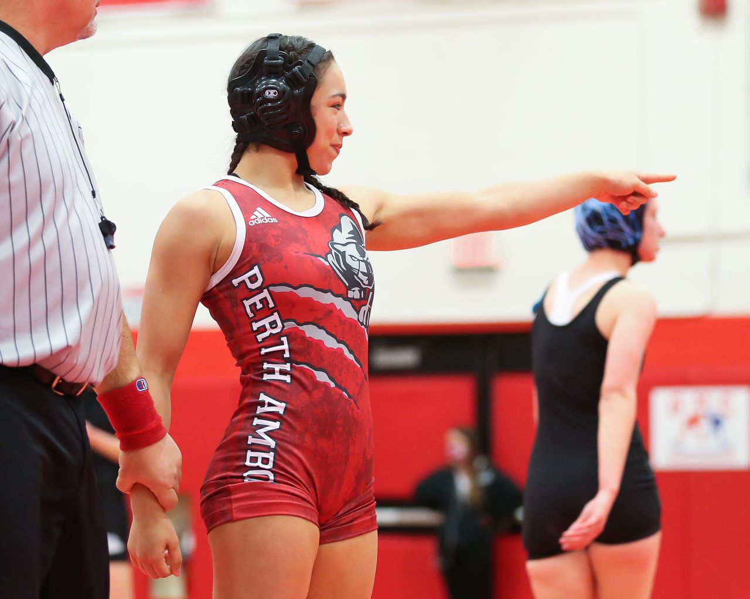

Ahsia Torres of Perth Amboy points to her corner after pinning Keira Walker of Metuchen during the 107 pound girls wrestling final of the Greater Middlesex Conference Tournament at St. Thomas Aquinas High School on 1/16/22.Tom Horak | For NJ Advance Media

748

shares

**By**[**Michael Holcombe | For NJ Advance Media**](http://www.nj.com/staff/mholcombe/posts.html)

No wrestler in the state dominated her weight class as thoroughly and completely as Perth Amboy’s Ahsia Torres did this season. She didn’t wrestle as many matches as some girls did but she went 18-0 and won a state title at 107 after having to sit out all last season due to her school shutting down its athletic programs.

For those reasons, Perth Amboy’s Ahsia Torres is the [NJ.com](http://nj.com/) Girls Wrestler of the Year for 2021-22.

After missing the 2020-21 season, Torres may have seemed like something of an unknown quantity to many but Perth Amboy coach Roberto Morales knew Torres was destined for a state title as early as February 2021 when she competed in a jamboree-style event put on by the Cordoba Wrestling Club.

“I’ll never forget it,” Morales said. “It was Valentine’s Day. There was something different about her that day. The way she wrestled. And she put the boom on Izabella Frezzo (the 2021 state champ at 107). She lost to her in states (in 2020) and came back to take fifth. She was no match for Ahsia. She was stronger and quicker and two weeks later she came back and put the boom on everybody at the Chick Classic and pinned Ava Rose (the 2022 state champ at 114). I knew there was something different about her. It was like, ‘I’m going to win everything and nobody is going to stop me.’”

As it turned out, no wrestler could stop her, but COVID did. Torres sat out the 2020-21 season and had to watch as her friends from the clubs competed in the high school season while she didn’t. In response, she doubled down on training, doing more weight conditioning and adding more wrestling both at the clubs and against the boys. Although she had never wrestled freestyle previously, she made the Junior National team and won three matches in Fargo against some of the top wrestlers in the country.

“It really was kind of difficult to even cope,” Torres said of the forced layoff. “My coaches were even thinking that maybe I should transfer just so I could wrestle. I didn’t end up doing that but I had to stay focused and stay motivated.”

So when this season finally came around, Torres hit the ground running. In the opening weekend she won the 107 pound title at the Queen of the East in Pennsauken by pinning 2021′s 100 pound state champion, Isabella Santos of Elizabeth, in less than a minute in the finals.

From there, Torres launched a reign of terror against her opponents for the rest of the season, crushing any challenge she faced. In compiling her 18 wins, she had 16 pins, with 14 of them coming in the first period. Only Somerville’s Valarie Maldonado, who finished third in the state at 114 this season, was able to go the full six minutes with Torres, losing a 14-0 major decision in the Lady Pioneers’ Invitational in January.

Hunterdon Central’s Evelyn Andrade, the third place finisher in the state at 107, also avoided hearing the slap of the mat against Torres, losing by technical fall 15-0 in 4:28 in the North Region semifinal.

Torres made short work of the North Region, pinning Bogota’s Theresa Zeppetelli in the first period in the final. She then cruised almost as easily through the state tournament at Phillipsburg a week later when she recorded a pair of first period pins before pinning Zeppetelli in the final again, this time in 4:55.

“Honestly, I was hungry,” Torres said of bulldozing her way through her regular and post season schedules. “My mindset was, I didn’t have a season and this was my chance to show off everything I was doing and how much I was improving. I had to keep that in my head every match.”

Torres tore through this year’s competition by utilizing a physical style combined with great speed and a practiced technique. Her coach feels those attributes have set her apart, not just from other girls wrestlers, but from most wrestlers, in general.

“She is the best wrestler I’ve ever coached,” Morales said of his state champ. “She just has a really high wrestling IQ. She knows what she’s doing out there. In the state final, I could see what she was planning out there. She makes adjustments on the fly in matches so fast. She doesn’t panic. She’s a brute. Before she goes out she might be a little nervous but as soon as she goes out there, it just clicks.

“She’s got great hips, great body awareness and great mat sense. You can’t teach that. When she came in as a freshman we were watching her doing things naturally, things I have tried to teach some of the guys to do for three years. We go over things with her and she just executes.

“Her moves in transition are by far the best I’ve seen. Not only from neutral, feet to back, but she is relentless on top. She suffocates her opponents with arm bars, cradles and half nelsons until she gets what she wants, a pin.”

Where Torres goes next with those skills still remains to be seen. Right now, Sacred Heart and East Stroudsburg are in the mix but other offers may be forthcoming. There will be another trip to Fargo and the Junior Nationals as well.

“I plan on wrestling in college,” Torres said of her future. “I’m ready for the next challenge.”